The X-]5 is a single-place, rocket-powered airplane designed for flight at hypersonic speeds and extreme altitudes. The airplane is carried aloft under the right wing of a B-52 and is launched at an altitude of about 45000 ft and a Mach number of about 0.80.
After launch, the X-J5 performs a powered flight mission, followed by a deceleration glide prior to vectoring for a landing. With this operational technique, the airplane is capable of attaining a Mach number of 6 and can be flown to and recovered from an altitude in excess of 300 000 feet.
Flights to high altitudes have been made with all three of the X-J5 airplanes in two configurations: the basic and the ventral off. The basic configuration is considered here.
Aerodynamic control is provided through conventional aerodynamic surfaces, with vertical surfaces used for yaw control and the horizontal tail for both pitch and roll control.
All of the aerodynamic control surfaces are actuated by irreversible hydraulic systems. Control force is provided by bungee for pilot feel.
A conventional center stick is used for pitch and roll control and rudder pedals are used for yaw control; however, a side-located stick is provided for control of pitch and roll in high-acceleration environments at the option of the pilot.
Most of the X-15 missions have been made with the side stick_ although the pilots used the center stick on their first flights.
Only the center stick control is shown here.
The augmentation system shown in this report consists of angular rate feedback loops about all three axes.
In addition to the normal p $δ_{a}$ roll SAS loop, there is an r $δ_{r}$ a feedback known as the YAR loop.
The gains for each SAS loop are manually set by the pilot.
The SAS-on transfer functions given for this airplane assume maximum gain settings for each loop.
This may not have been realistic for actual flights.
The flight conditions considered for this airplane are all for straight and level trimmed flight. This is definitely unrealistic for this airplane_ however, the intent here is to show general speed and altitude variation effects.

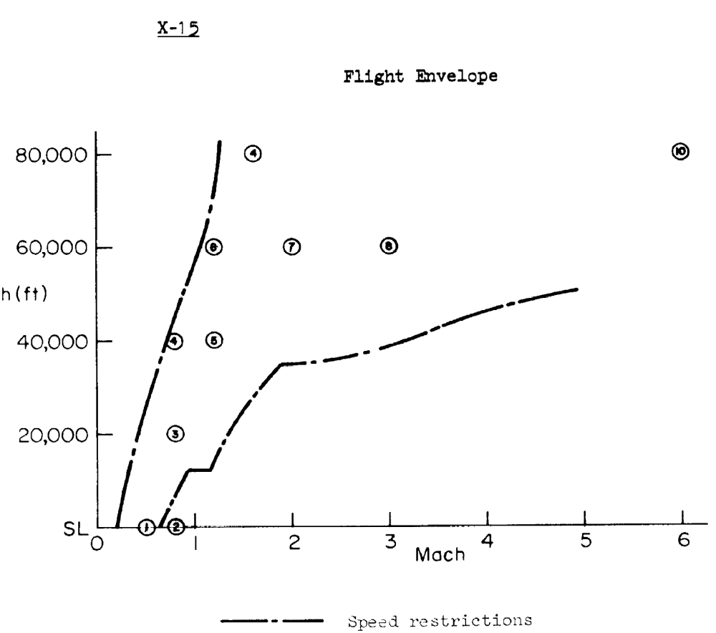

Nominal configuration :

Aircraft mass m = 7063 kg

Gravity center location $\overline{X_{CG}}=0.22$

$$I_{XX}=4951.7 kg m^{2}$$

$$I_{YY}=108511 kg m^{2}$$

$$I_{ZZ}=111224 kg m^{2}$$

$$I_{XZ}=122 kg m^{2}$$

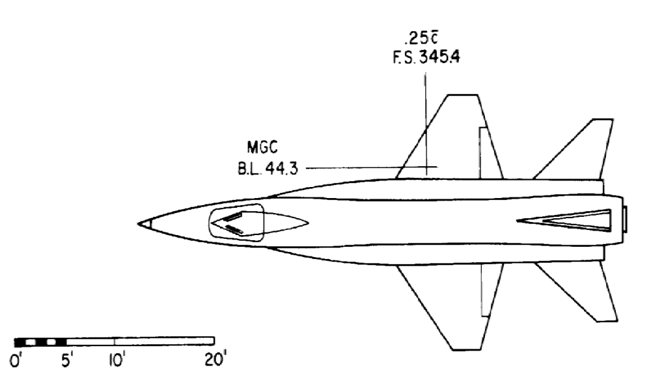

Flight conditions
Altitude | 12192 | m
air density | 0.302 | kg/m3
speed | 235.9 | m/s
Mach number | 0.80
initial attitude theta 0 | 7.5 | deg

Geometric data
wing area | 18.58 | m2
wing span | 6.82 | m
wing mean chord | 3.13 | m
Aspect ratio | 2.50
Oswald factor | 0.93

Steady state conditions
CL0 | 0.42
CD0 | 0.13
CTx0 | 0.025
Cm0 | 0
Cmt0 | 0

Aerodynamic deravatives
Cmu | -0.1
Cm alpha | -1
Cm alpha dot | -1.6
Cmq | -12.5
Cm t u | 0
Cm t alpha | 0
C L u | 0
C L alpha | 4
C L alpha dot | 0
CLq | 0
C D u | 0
C D alpha | 0.8
C D alpha dot | 0
C Dq | 0
C T u | 0
C L delta e | 1.1
C D delta e | 0
C m delta e | -1.5

Longitudinal Dynamic Stability
of Airplane

The objective of this homework is to study the stability modes of an aircraft which we knew his geometric, inertial and aerodynamic data.
For attempting this objective, you will find by using Matlab:
- Equations of longitudinal motion.
- The matrix A of aircraft
- The characteristic equation
- The eigenvalues (roots of equation) of the system
- Different modes of longitudinal stability
  - Short period mode (Natural Frequency, Damping Factor)
  - Phegoid mode (Natural Frequency, Damping Factor)
- Curves of longitudinal motion:
  - Axial velocity in function of time
  - Angle of attack
  - Pitch rate
  - Pitch angle
- Transfer Functions of Each variable

